1. **Agenda**:
   1. What is Lambda Expression?
   2. How to write it?
   3. How they are different from the existing way of how we write methods.
   4. Functional Interface.
2. @FunctionalInterface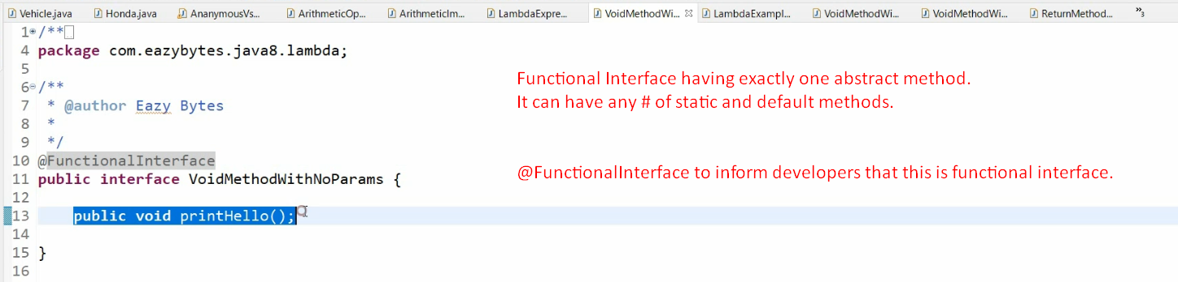
3. In lambda expression, we don’t to give any name, access modifier and input and output parameter types and this is achieved with functional interface.
4. 